|  |  |
| --- | --- |
| MULTI-TIER FEEDBACK MANAGEMENT SYSTEM | Dhivya Lakshmi S  Cloud Computing Technologies |

**Table of Contents**

1. **Project Overview 2**
2. **Phase 1: Architecture Highlights 2**
   * **Web Tier**
   * **App Tier**
   * **Database Tier**
   * **Architecture Diagram**
3. **Phase 2: Key AWS Services Used 4**
4. **Phase 3: Step-by-Step Implementation 4**
   * **Step 3.1: Create VPC & Networking**
   * **Step 3.2: Security Groups**
   * **Step 3.3: Database Tier Setup**
   * **Step 3.4: IAM Role for App EC2**
   * **Step 3.5: Route 53 Configuration**
5. **Phase 4: Auto Scaling Configuration 14**
   * **AMI Setup**
   * **Launch Template**
   * **Auto Scaling Group (ASG)**
   * **ALB Configuration**
   * **Scaling Policy**
6. **Phase 5: Multi-Tier & Auto Scaling Demonstration 17**
   * **Multi-Tier Proof**
   * **Auto Scaling Proof**
7. **Phase 6: Amazon Quick Sight Visualization 24**
8. **Phase 7: Key Learnings and Challenges Faced 25**
9. **Phase 8: Future Enhancements 26**
10. **Conclusion 27**

**PROJECT OVERVIEW**

The **Multi-Tier Feedback Management System** is a cloud-native application built on **Amazon Web Services (AWS)**. It enables users to submit feedback through a web application, automatically performs **AI-powered sentiment analysis** using Amazon Comprehend, and visualizes insights using **Amazon Quick Sight dashboards**.

This project demonstrates how cloud technologies can be used to build **scalable, secure, and intelligent applications** that are ready for real-world traffic.

The system is designed in **three key layers**:

* **Web Tier:** User interface hosted on EC2 servers where feedback is submitted.
* **Database Tier:** Two RDS PostgreSQL databases – one for raw feedback and another for analyzed results.
* **Analysis & Visualization:** Feedback is processed by Amazon Comprehend, and insights are displayed in interactive Quick Sight dashboards.

To ensure **scalability and reliability**, the system uses **Application Load Balancers (ALB)** and **Auto Scaling Groups (ASG)**. This allows the application to dynamically adjust capacity based on incoming traffic.

**PHASE 1: ARCHITECTURE HIGHLIGHTS**

The system is built using a multi-tier design, which means different parts of the app are separated to improve security and performance.

Here’s how the tiers work:

* Web Tier: Handles user requests through EC2 servers behind a public Application Load Balancer (ALB). This is where users interact with the app.
* App Tier: Runs the backend logic on EC2 instances behind an internal ALB. It processes feedback, calls Amazon Comprehend to analyze sentiment, and interacts with the databases.
* Database Tier: Contains two Amazon RDS databases (in private subnets) — one for storing raw feedback, and another for storing analyzed results.

Each tier is placed in its own subnet and controlled with Security Groups that only allow necessary traffic, keeping the system secure and organized.

**Architecture Diagram:**

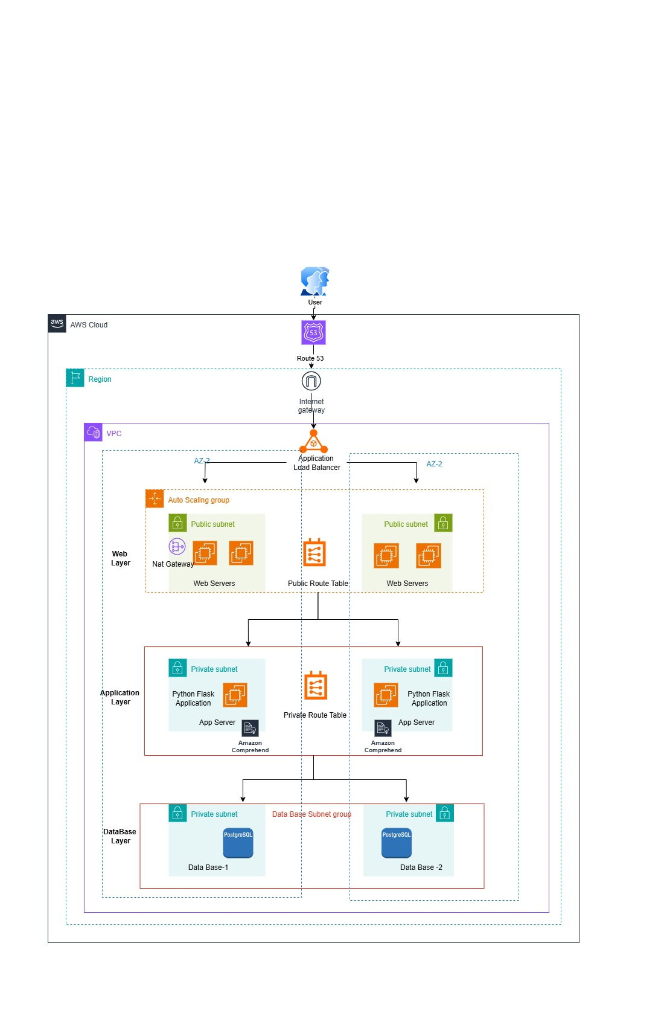

**PHASE 2. KEY AWS SERVICES USED**

|  |  |
| --- | --- |
| **Web Tier** | EC2, Auto Scaling, Internet-facing ALB |

|  |  |
| --- | --- |
| **App Tier** | EC2, Amazon Comprehend, Auto Scaling, Internal ALB |

|  |  |
| --- | --- |
| **Database Tier** | Amazon RDS (PostgreSQL) |

|  |  |
| --- | --- |
| **Visualization** | Amazon Quick Sight |

|  |  |
| --- | --- |
| **Networking** | VPC, Subnets, Route 53, Security Groups, IAM |

**PHASE 3. STEP-BY-STEP IMPLEMENTATION**

**Step 3.1: Create VPC & Networking**

VPC (Virtual Private Cloud) is like your own private network in AWS, where you control how resources communicate and access the Internet.

* Public Subnets: These host resources that need to be accessed from the Internet, like your Web Tier EC2 servers.
* Private Subnets: These host resources that should not be directly accessible from the Internet, like your App and Database tiers, enhance security.
* Internet Gateway: A connection between your VPC and the Internet, allowing public subnets to send and receive traffic.
* Route Tables: Rules that direct network traffic within the VPC and to the Internet, ensuring communication between subnets and proper traffic flow.
* Create a custom VPC with public and private subnets across multiple Availability Zones.
* Public subnets for Web Tier, private subnets for App and DB tiers.
* Create and attach an Internet Gateway.
* Configure route tables for proper traffic flow.

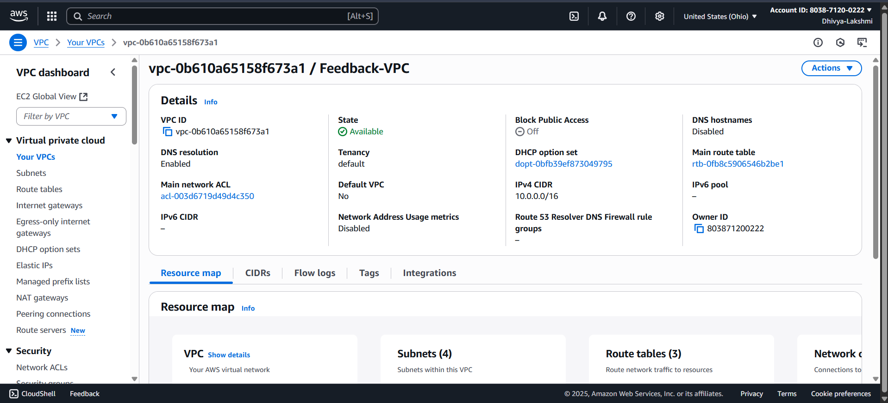

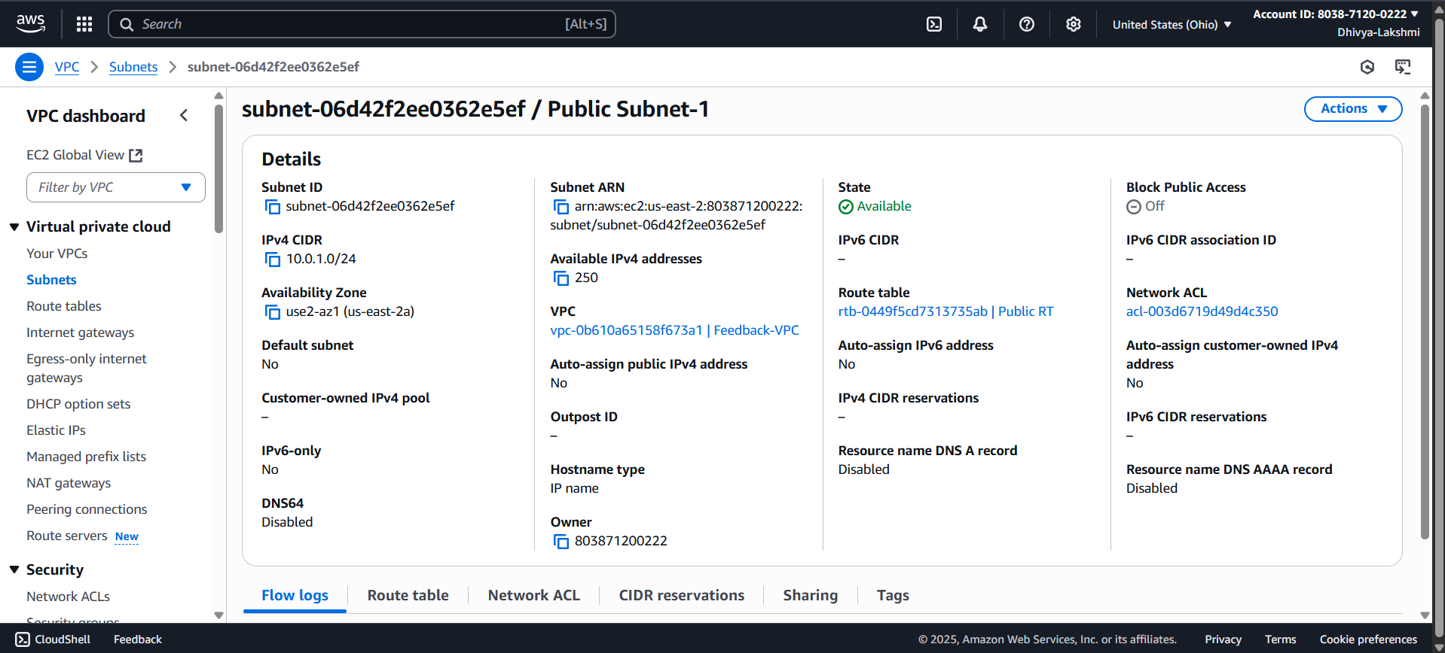

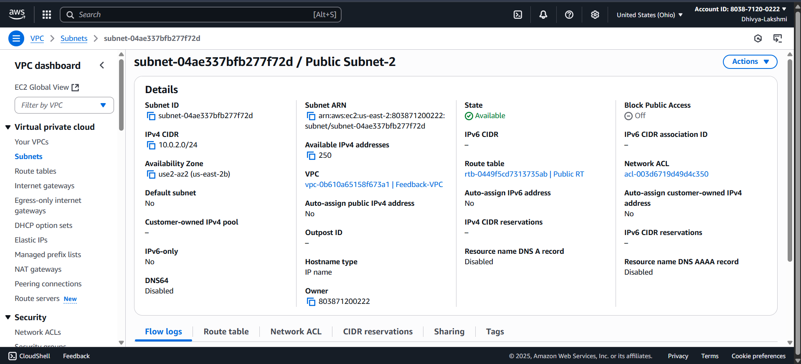

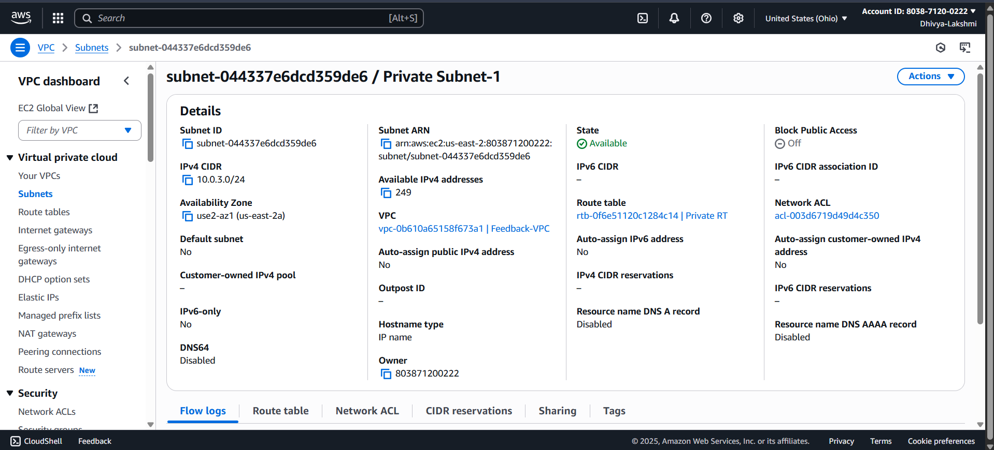

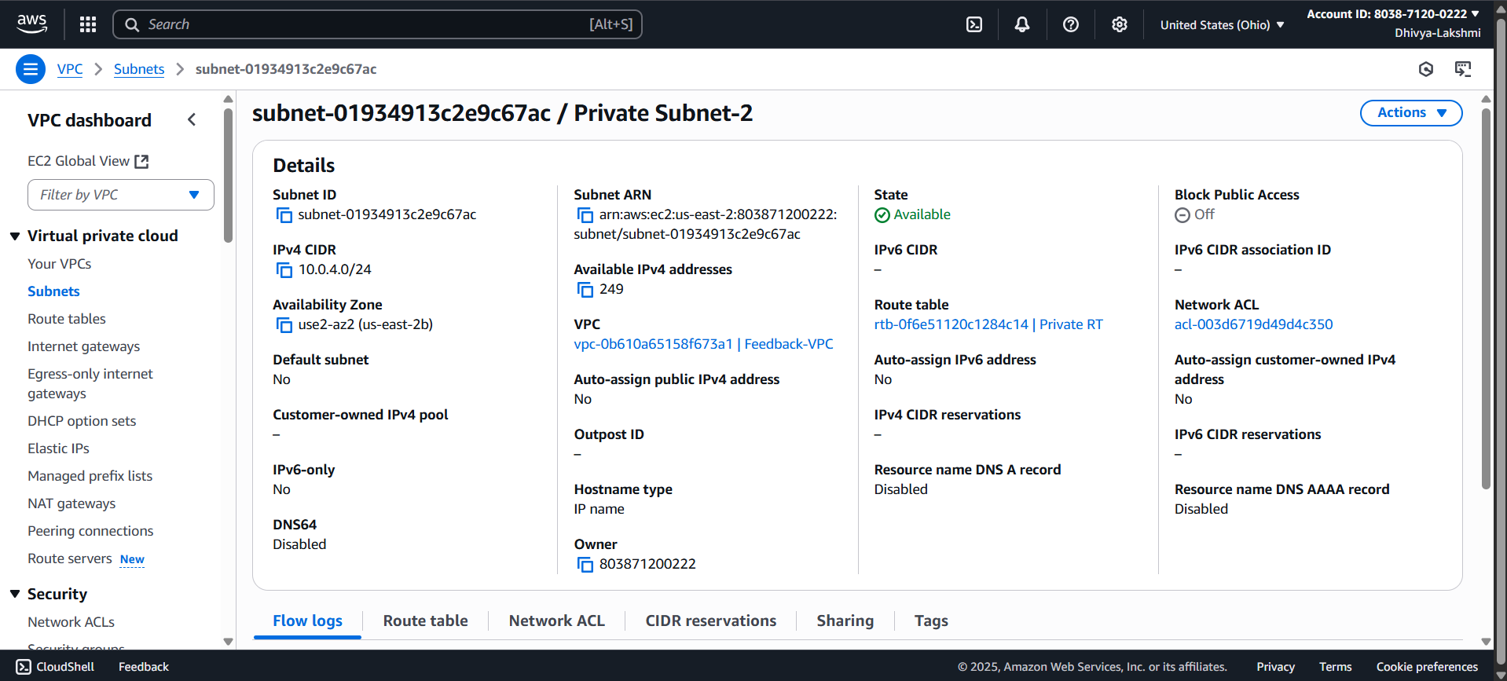

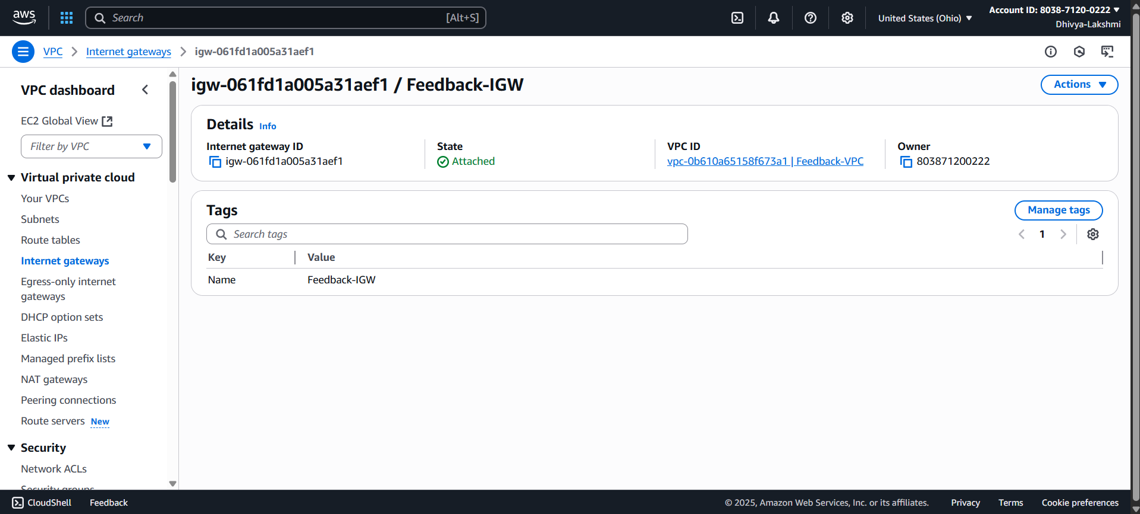

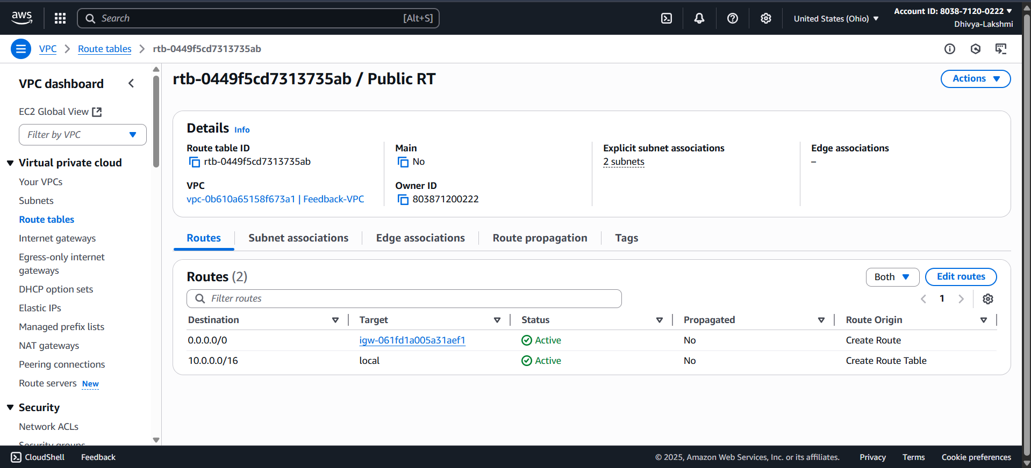

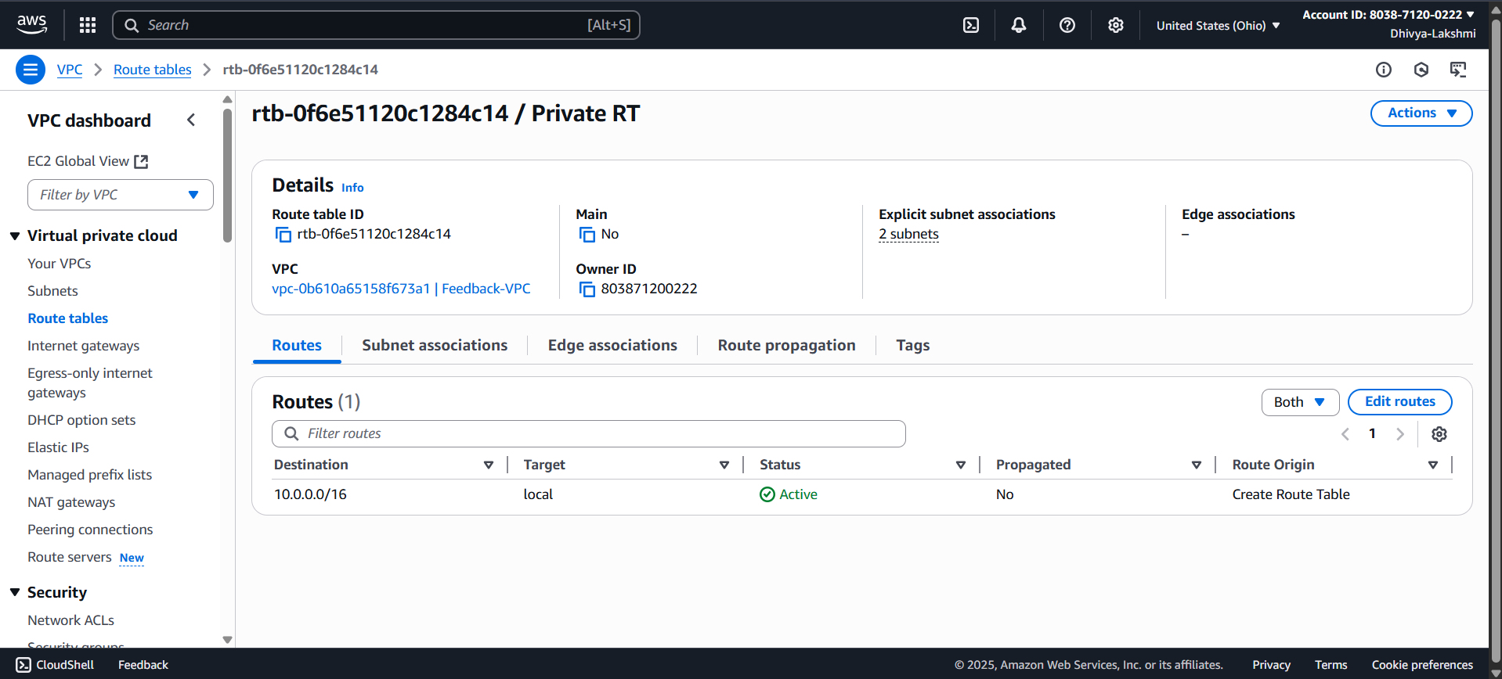

**Step 3.2: Security Groups**

* **Web ALB SG** → Allow HTTP (80) from 0.0.0.0/0.
* **Web EC2 SG** → Allow HTTP (80) from Web ALB SG.
* **App EC2 SG** → Allow HTTP (80) from App ALB SG.
* **DB SG** → Allow MySQL (3306) from App EC2 SG.

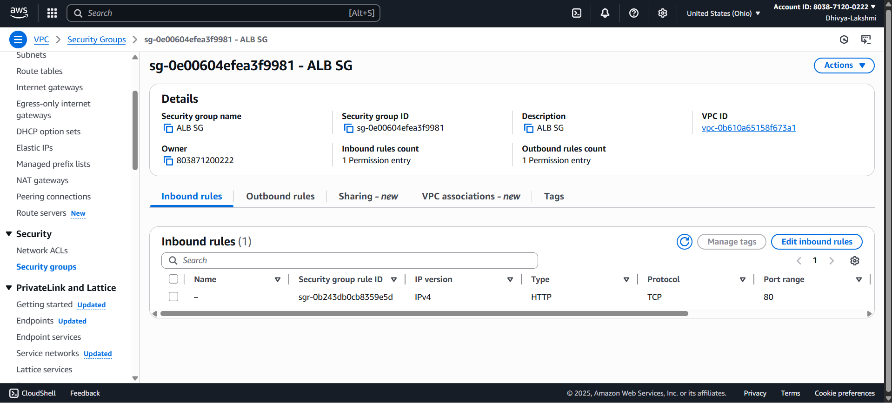

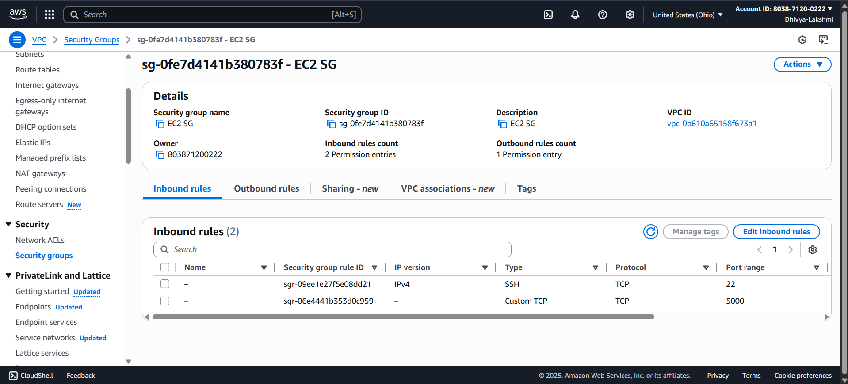

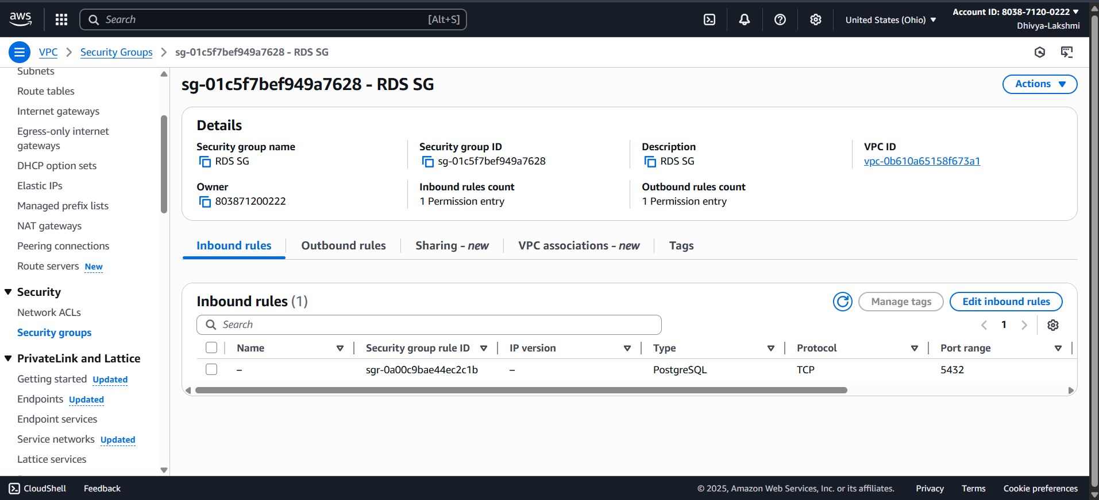

**Step 3.3: Database Tier Setup**

* Create **DB1** (Raw feedback) and **DB2** (Analyzed feedback) in Amazon RDS.
* Place both in private subnets.
* Allow only App Tier EC2 SG access.

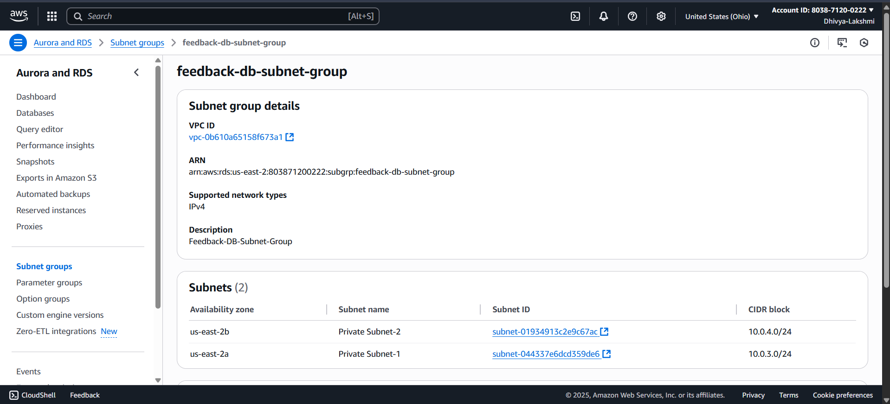

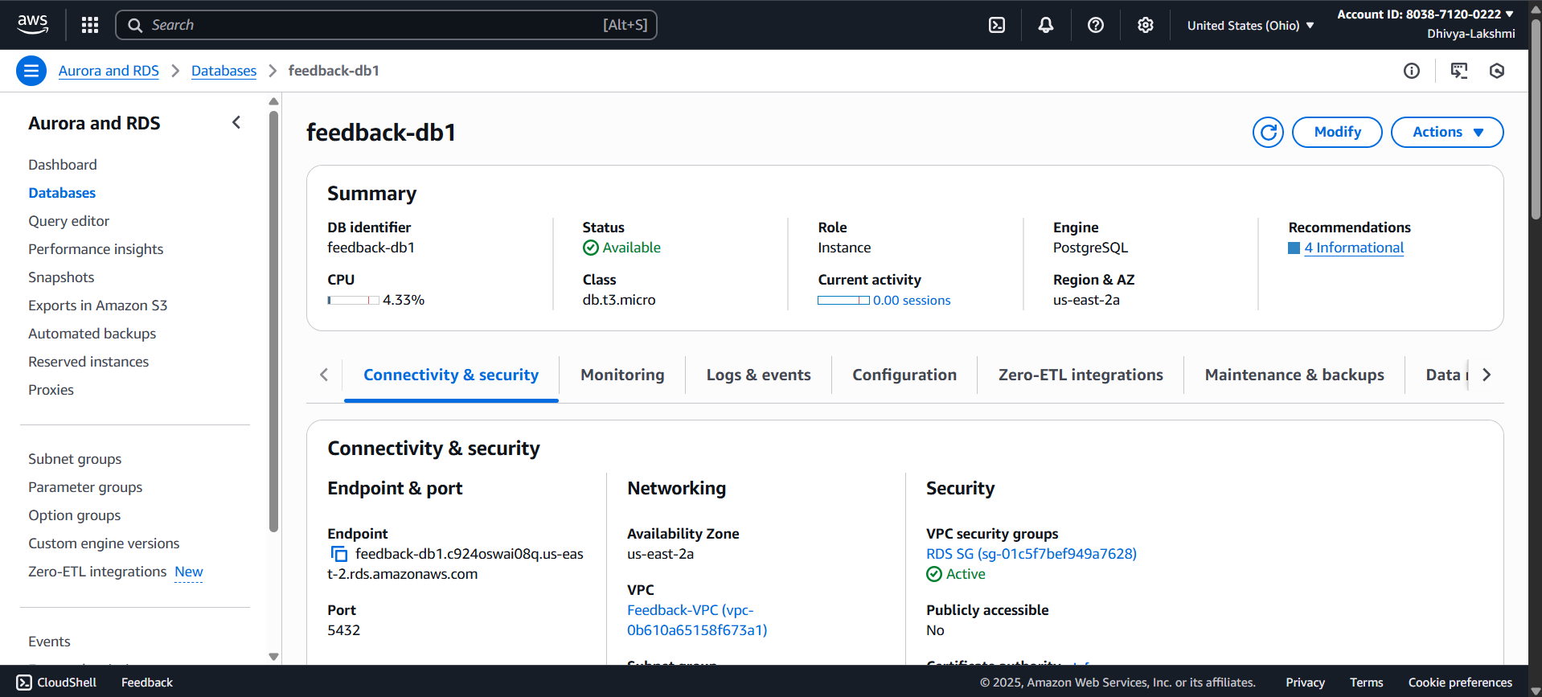

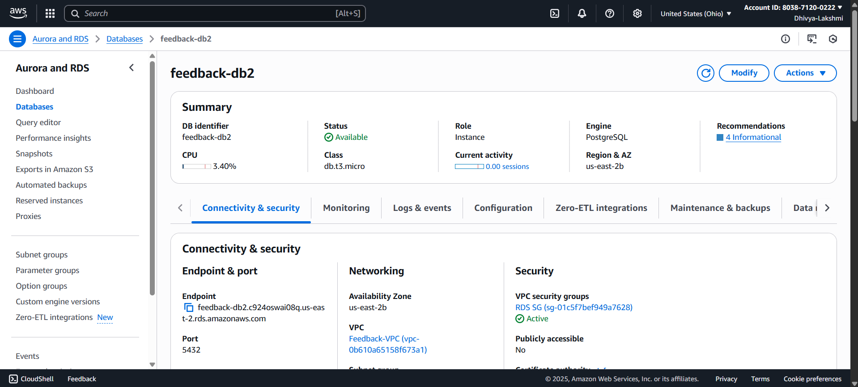

Step 3.4: Give your App EC2 permissions to call Amazon Comprehend so your sentiment analysis works. Create an IAM Role for your App EC2

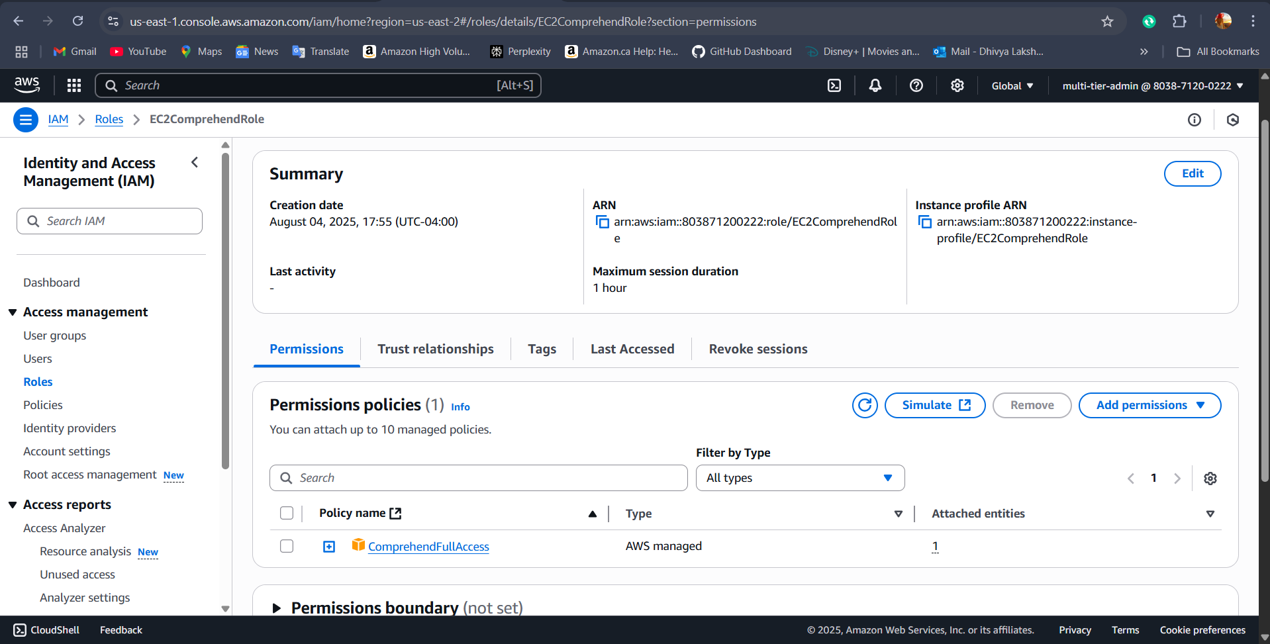

**Attach the role to your App EC2 instance**

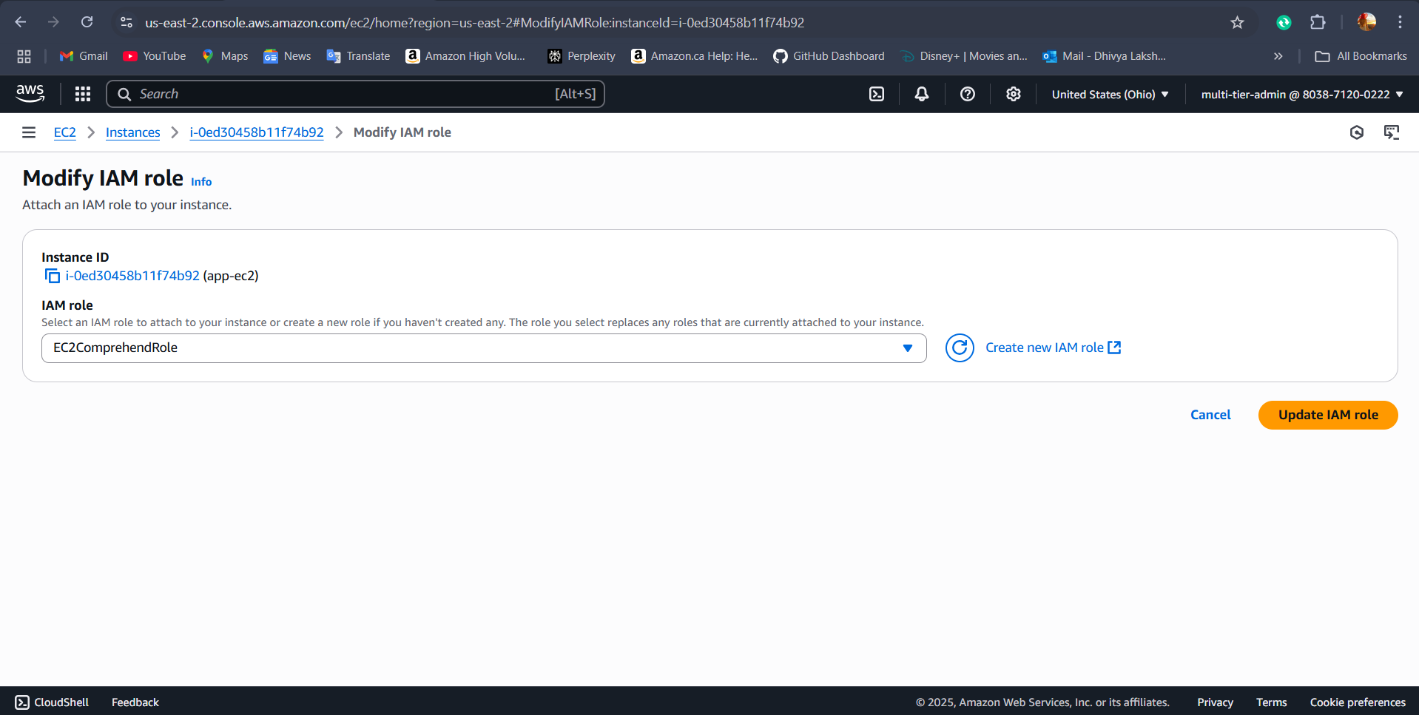

**Step 3.5: Route 53 configuration**

Amazon Route 53 is a scalable and reliable Domain Name System (DNS) service that routes users to your application. It allows you to use a custom domain name instead of the default ALB URL.

* **Create a Hosted Zone** in Route 53 with your domain name.
* **Add an A record** that points your domain to your ALB (feedback-alb-962958100.us-east-2.elb.amazonaws.com).
* **Update your domain registrar** with the NS records from Route 53.

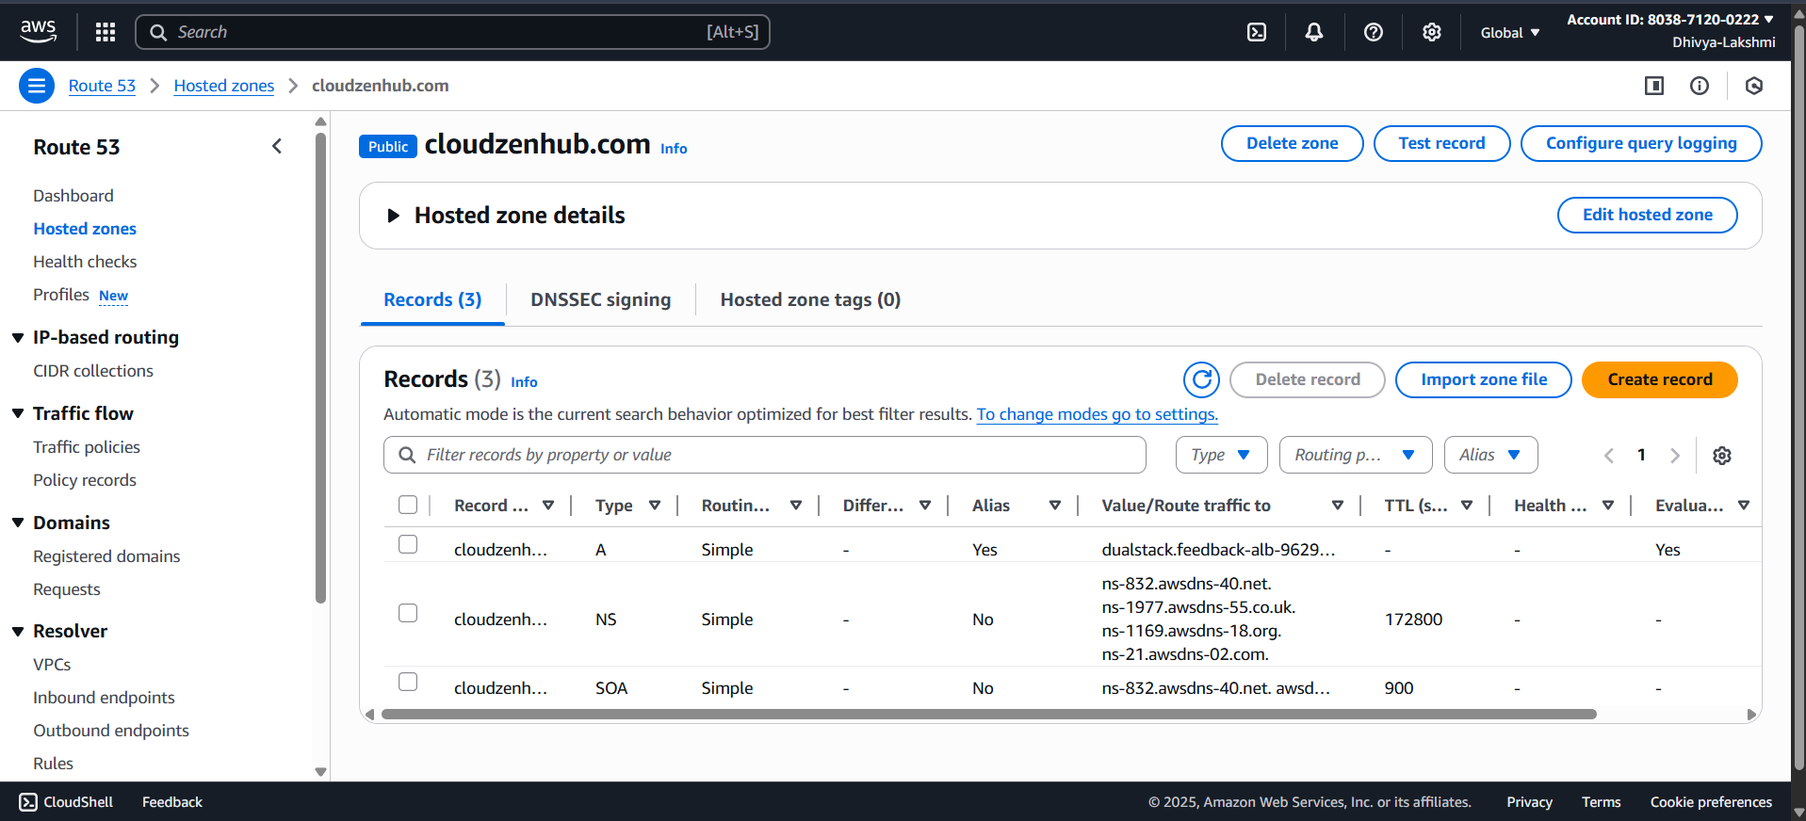

**PHASE 4. AUTO SCALING CONFIGURATION:**

Auto Scaling automatically adjusts the number of EC2 instances in your application based on traffic and load. This ensures your system remains responsive during high demand and cost-effective during low usage.

* **AMI**: Prebuilt image with required software
  + Web AMI: Apache + website files

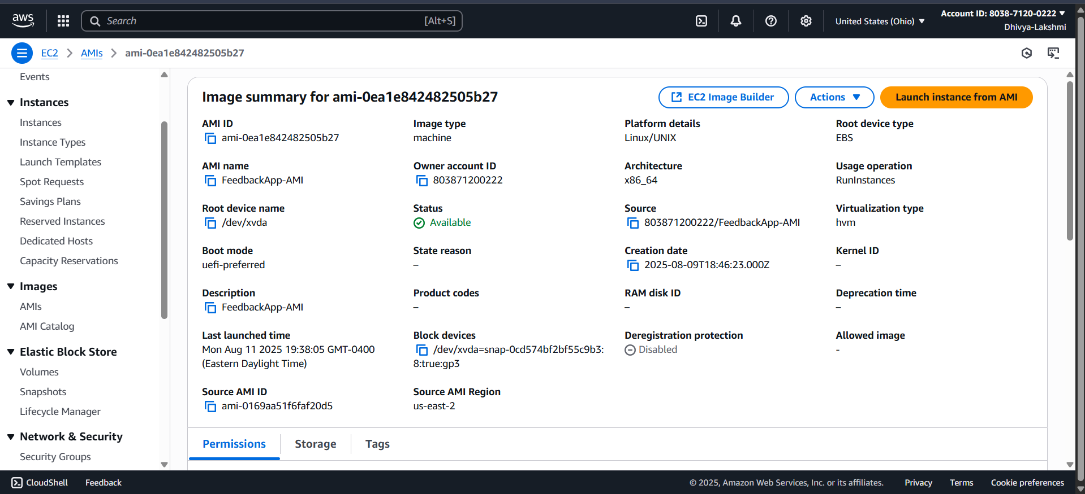

* **Launch Template** (per tier)
  + AMI ID, instance type, SGs, IAM role
  + User data (start Apache / start Flask)

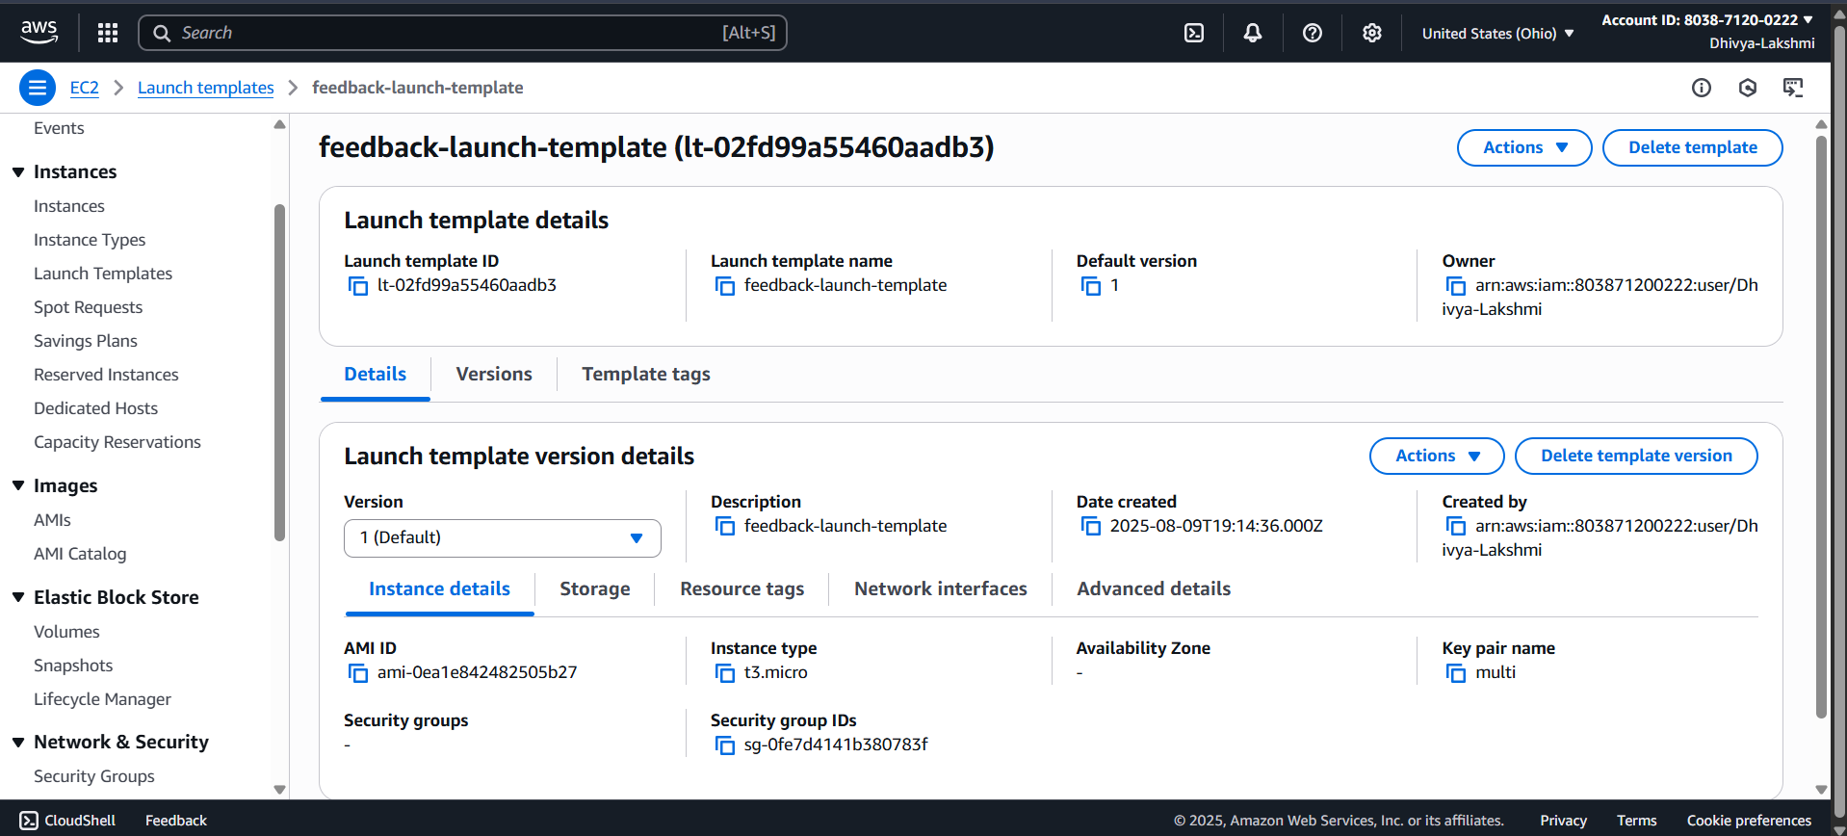

**ASG (Auto Scaling Group)**

* + Min: 1 • Desired: 1 • Max: 3
  + Uses the Launch Template
  + Attached to a Target Group

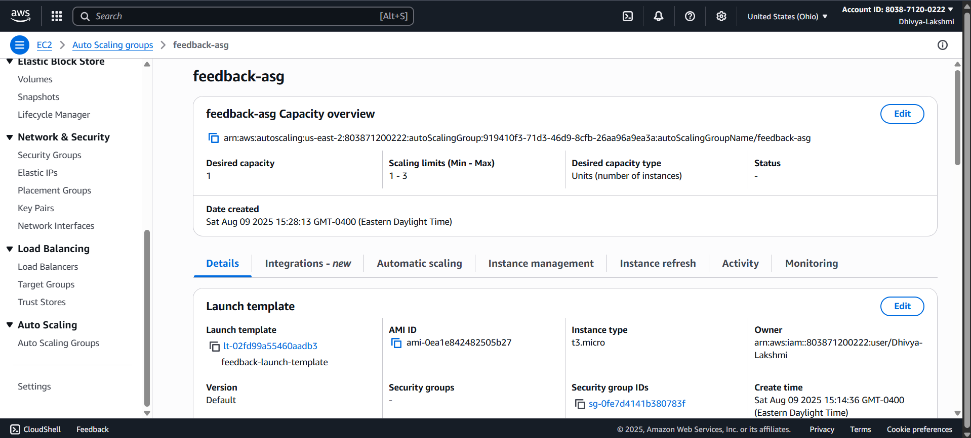

* **ALB (Application Load Balancer)**
  + Web: Public ALB → Web TG
  + App: Internal ALB → App TG
  + Health checks enabled

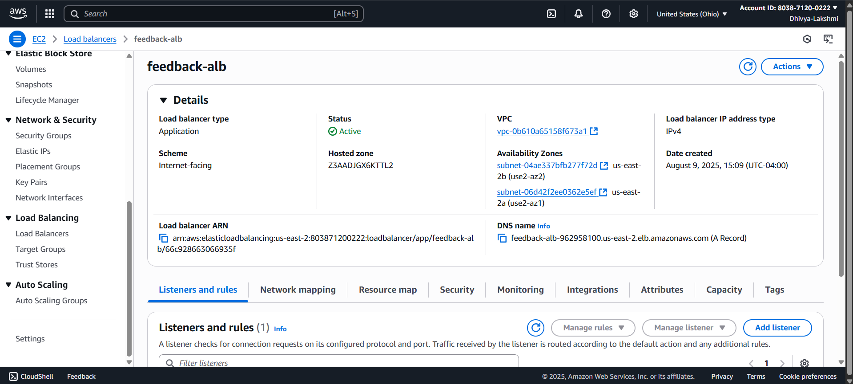

**Scaling Policy (Requests-based)**

* + Metric: RequestCountPerTarget (from ALB TG)

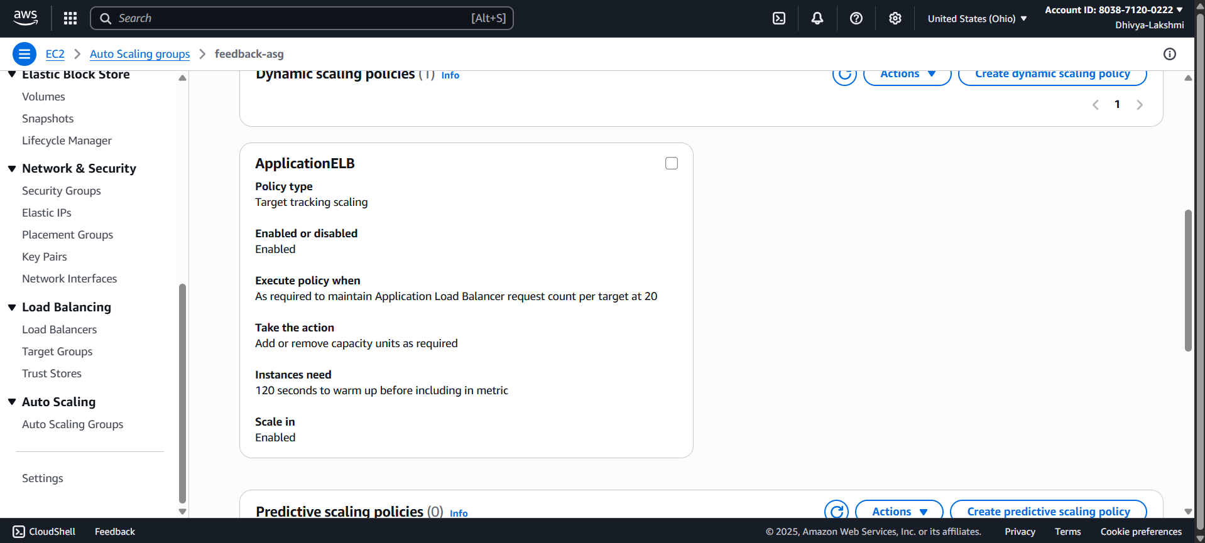

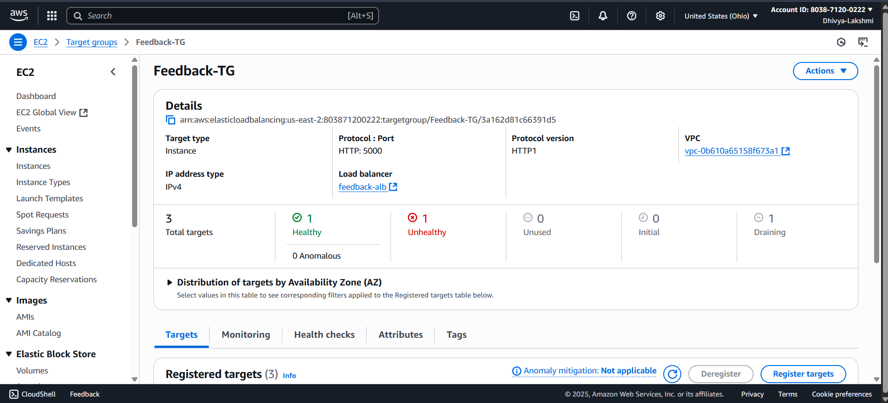

**PHASE 5. MULTI-TIER & AUTO SCALING ARE PROVEN IN THE DEMO**

**Multi-Tier Proof**:

* User submits feedback from the browser.
* App Tier (Python Flask) stores raw text in DB1.
* Sends text to Amazon Comprehend for sentiment analysis.
* Stores analyzed result in DB2.

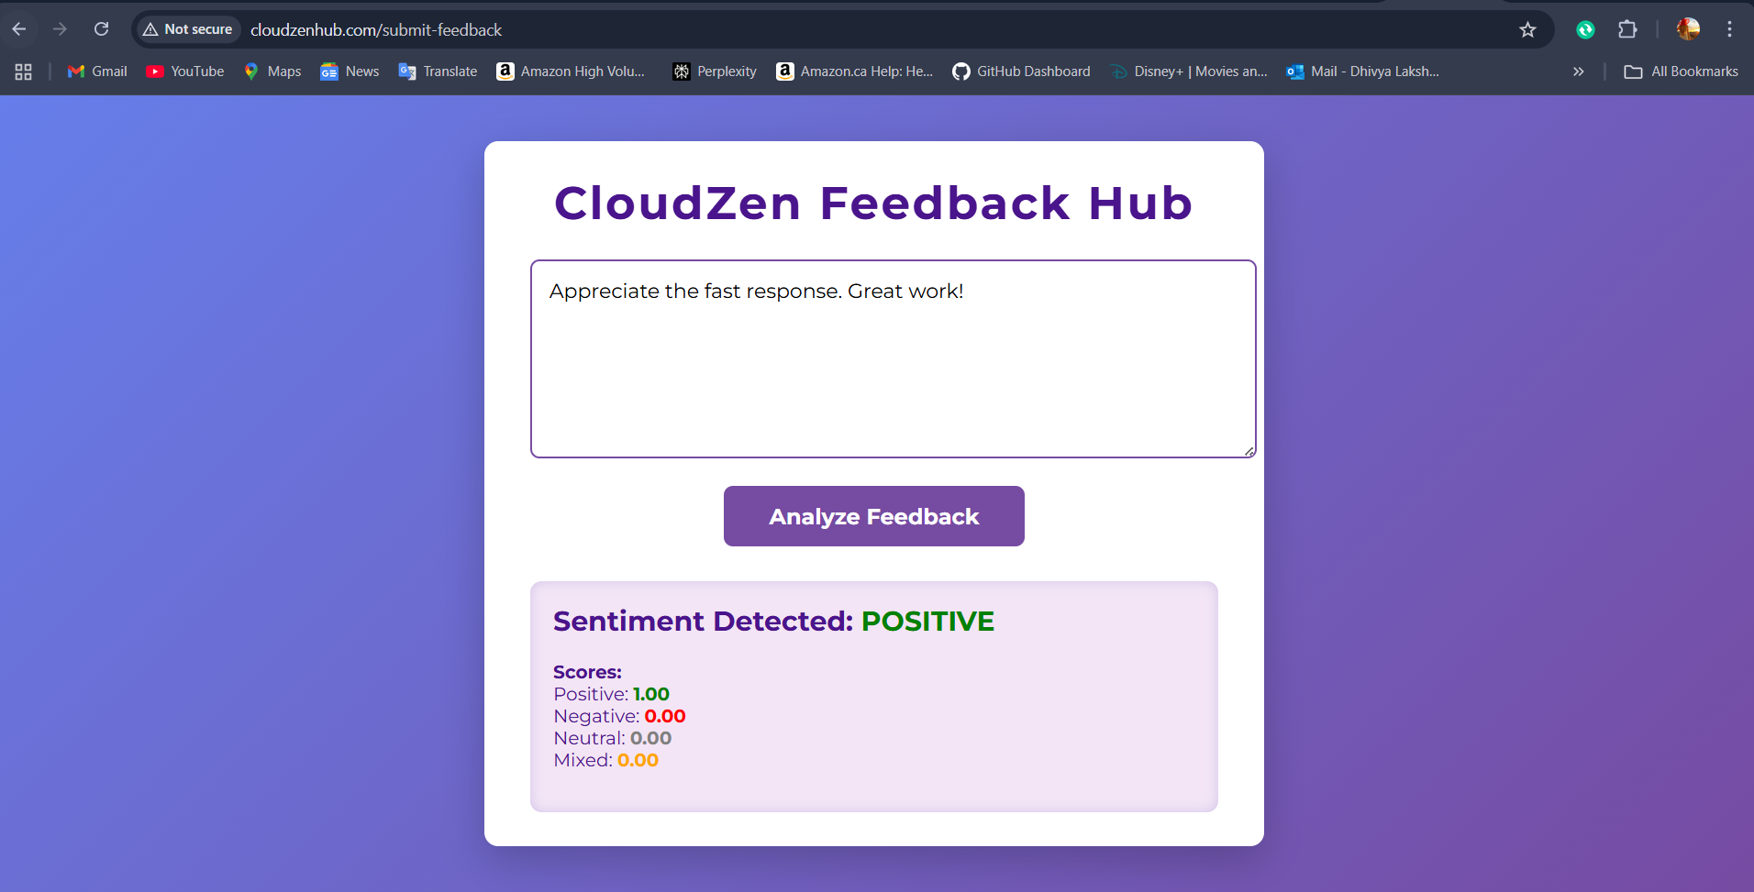

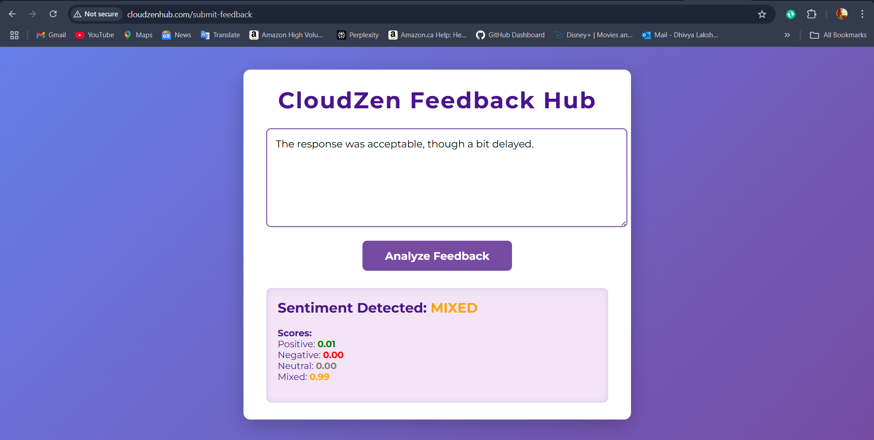

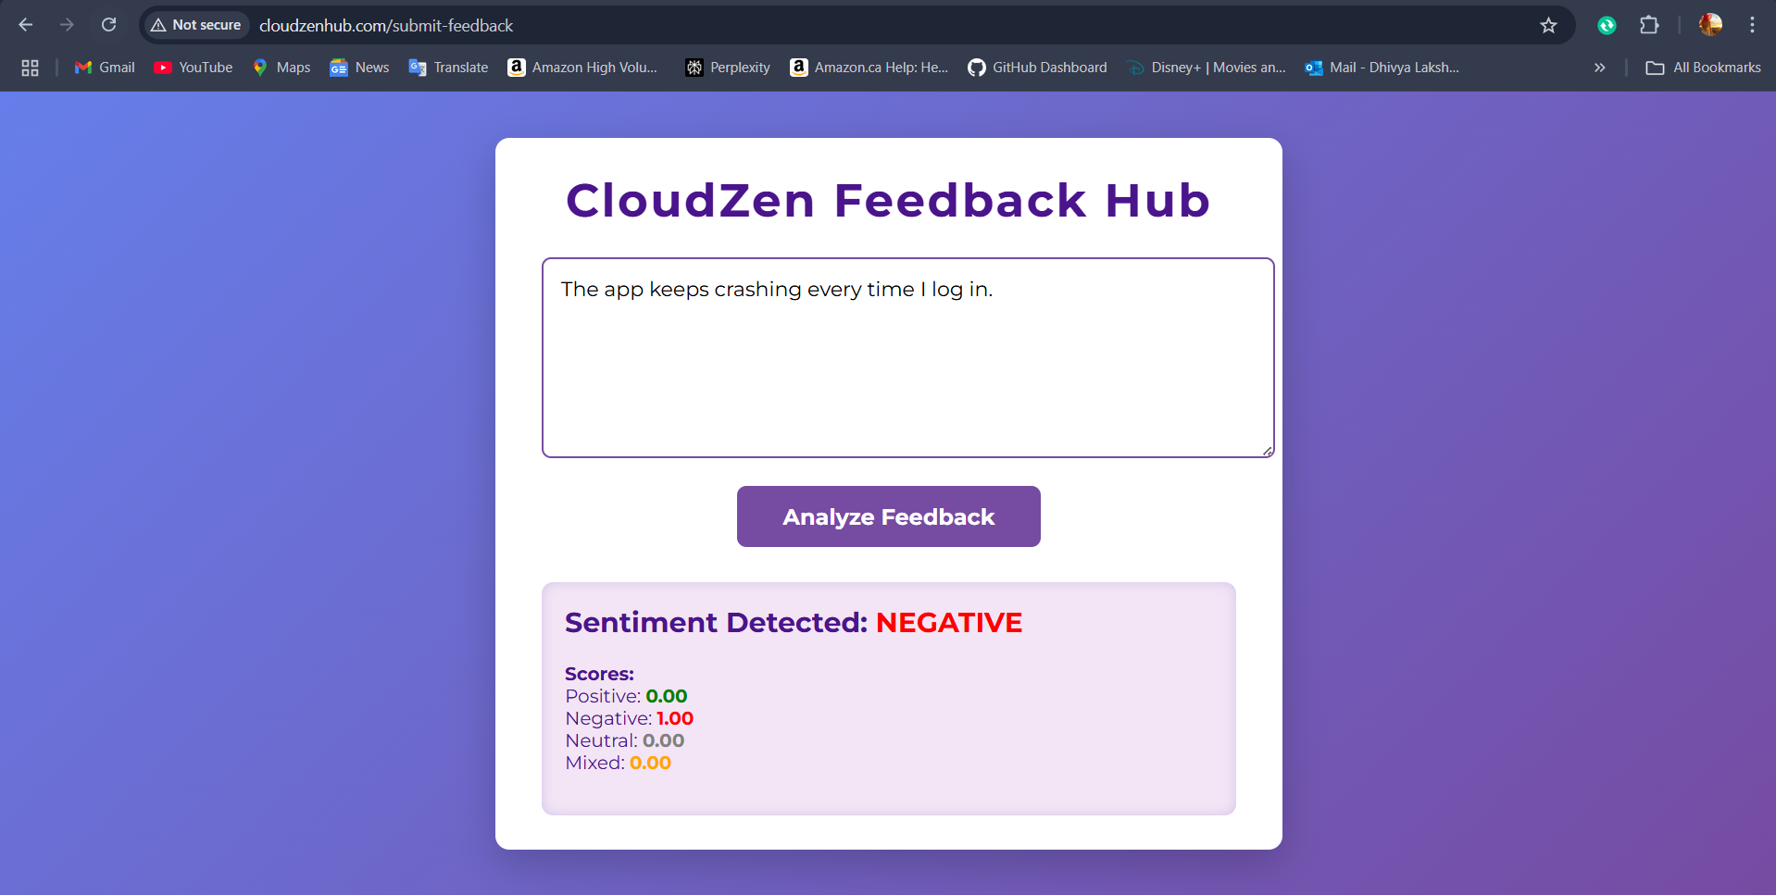

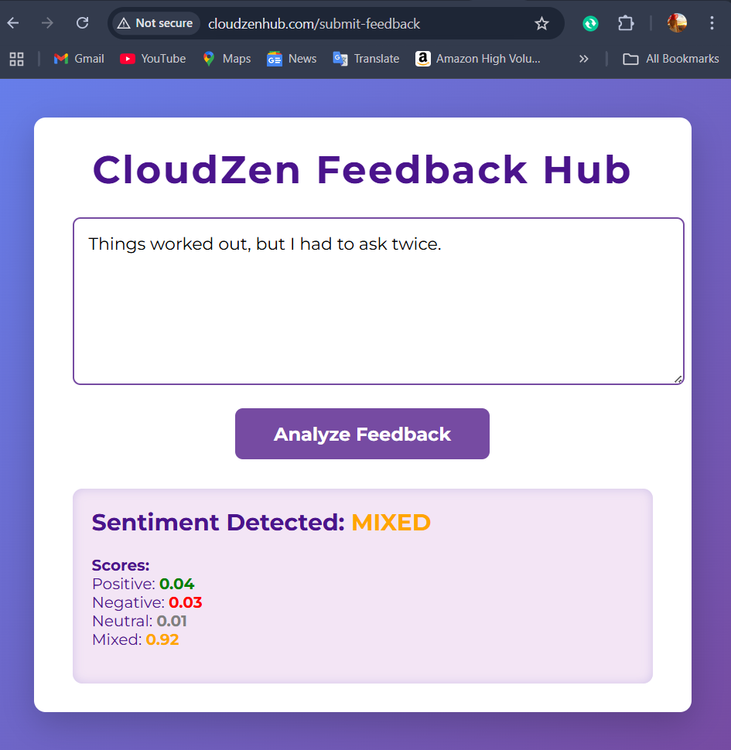

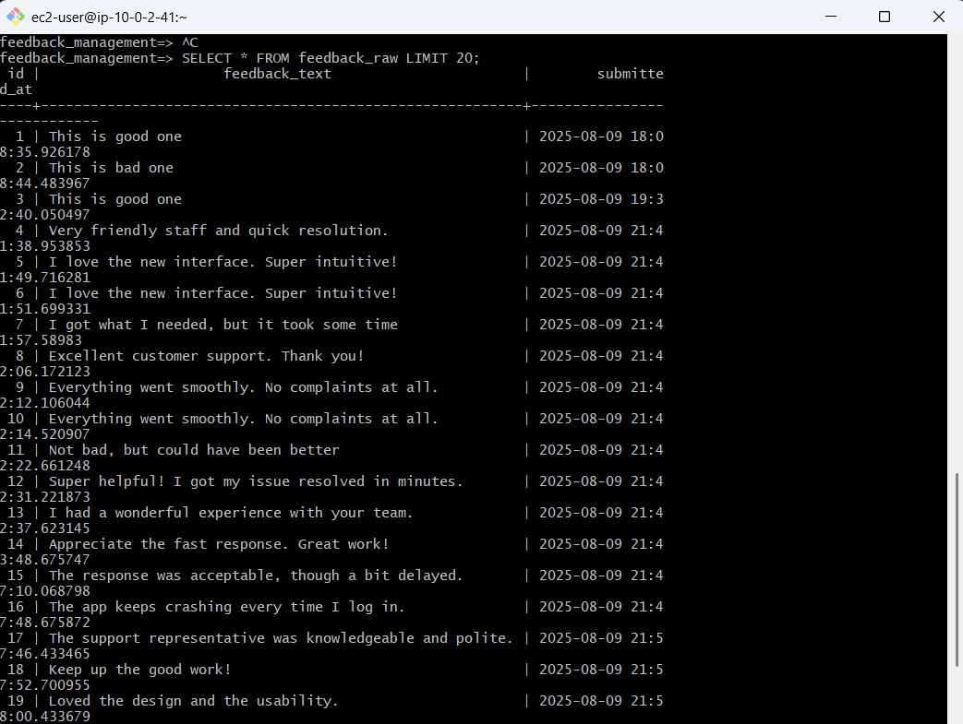

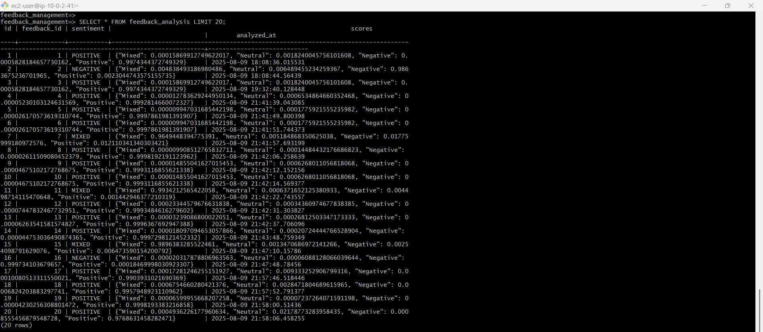

**Auto Scaling**

* **Scale Out:** When the number of feedback requests increases, **CloudWatch monitors the RequestCountPerTarget metric**. If it exceeds the threshold, the **Auto Scaling Group (ASG) automatically launches new EC2 instances** to handle the traffic.
* **Scale In:** When requests decrease below the threshold, CloudWatch triggers the scale-in policy, and the **ASG terminates extra EC2 instances**, returning to minimum capacity.

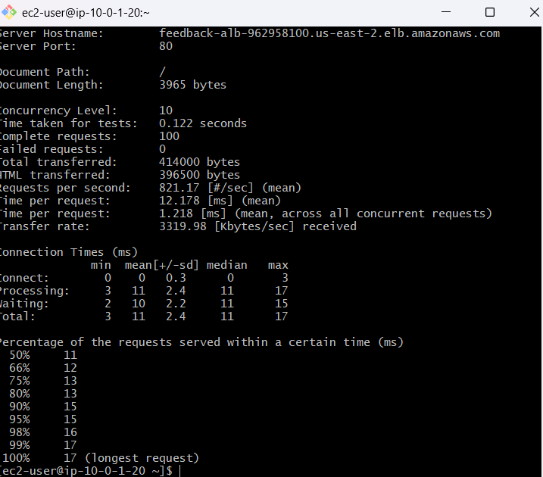



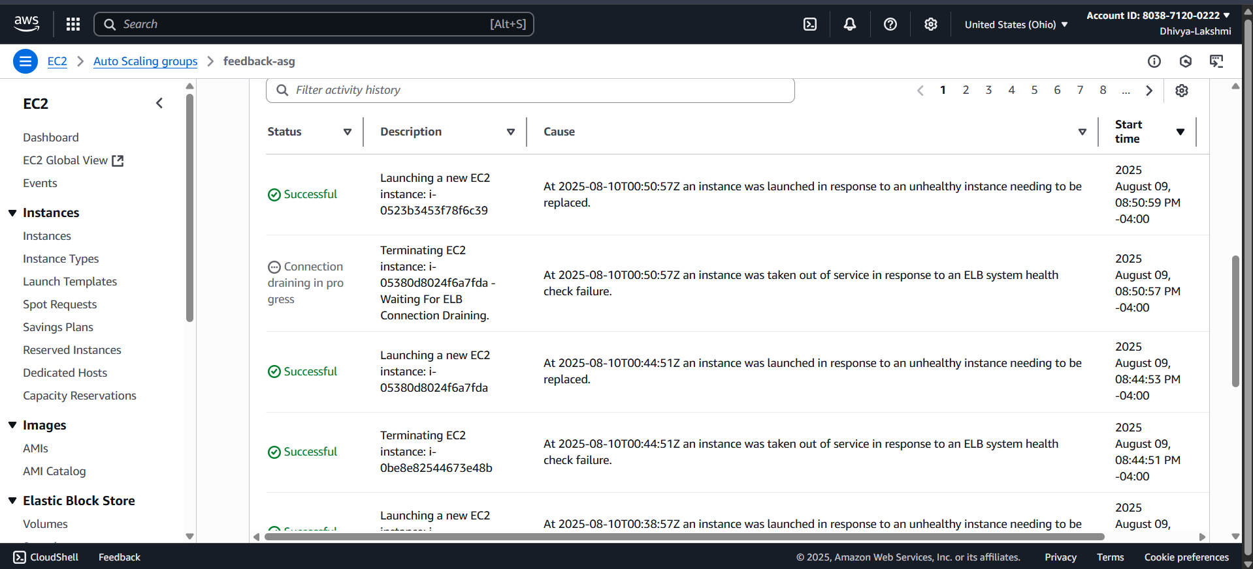

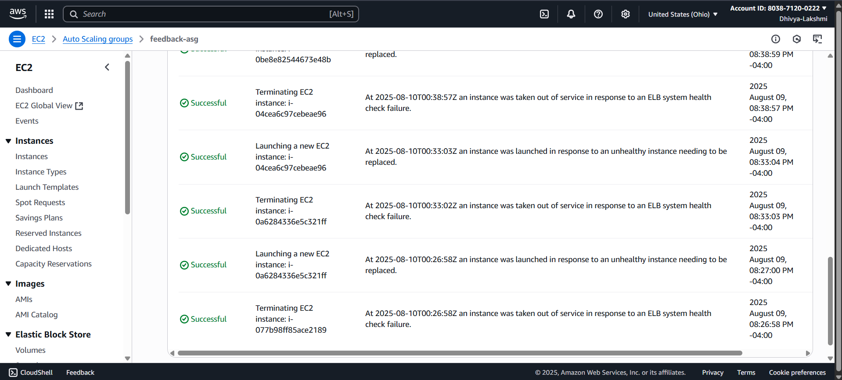

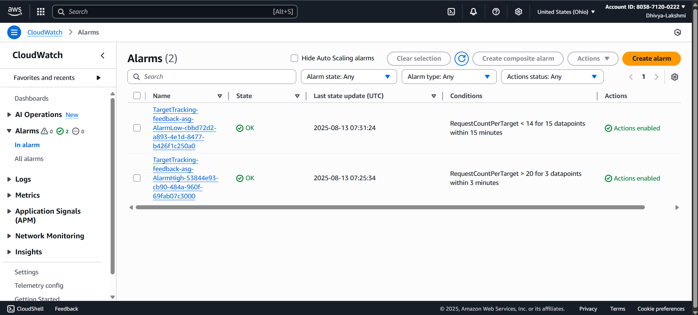

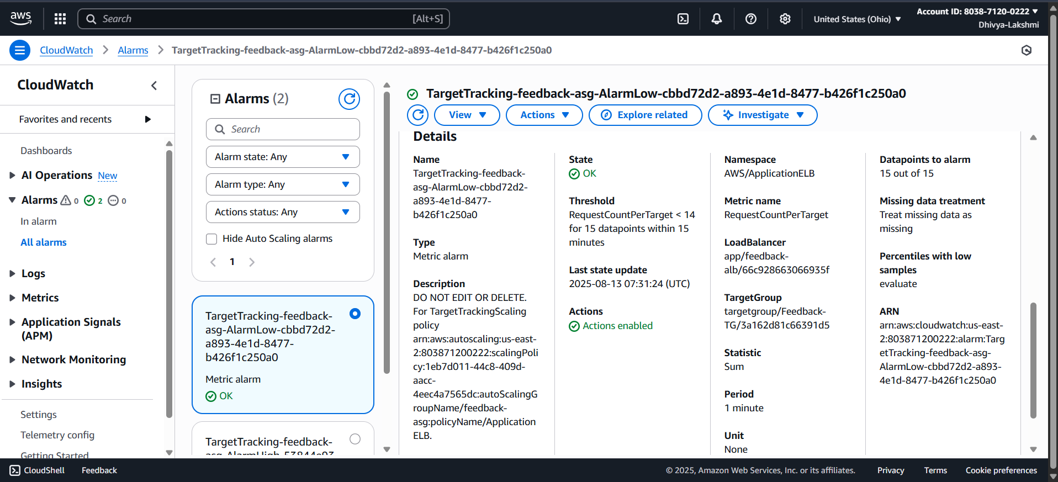

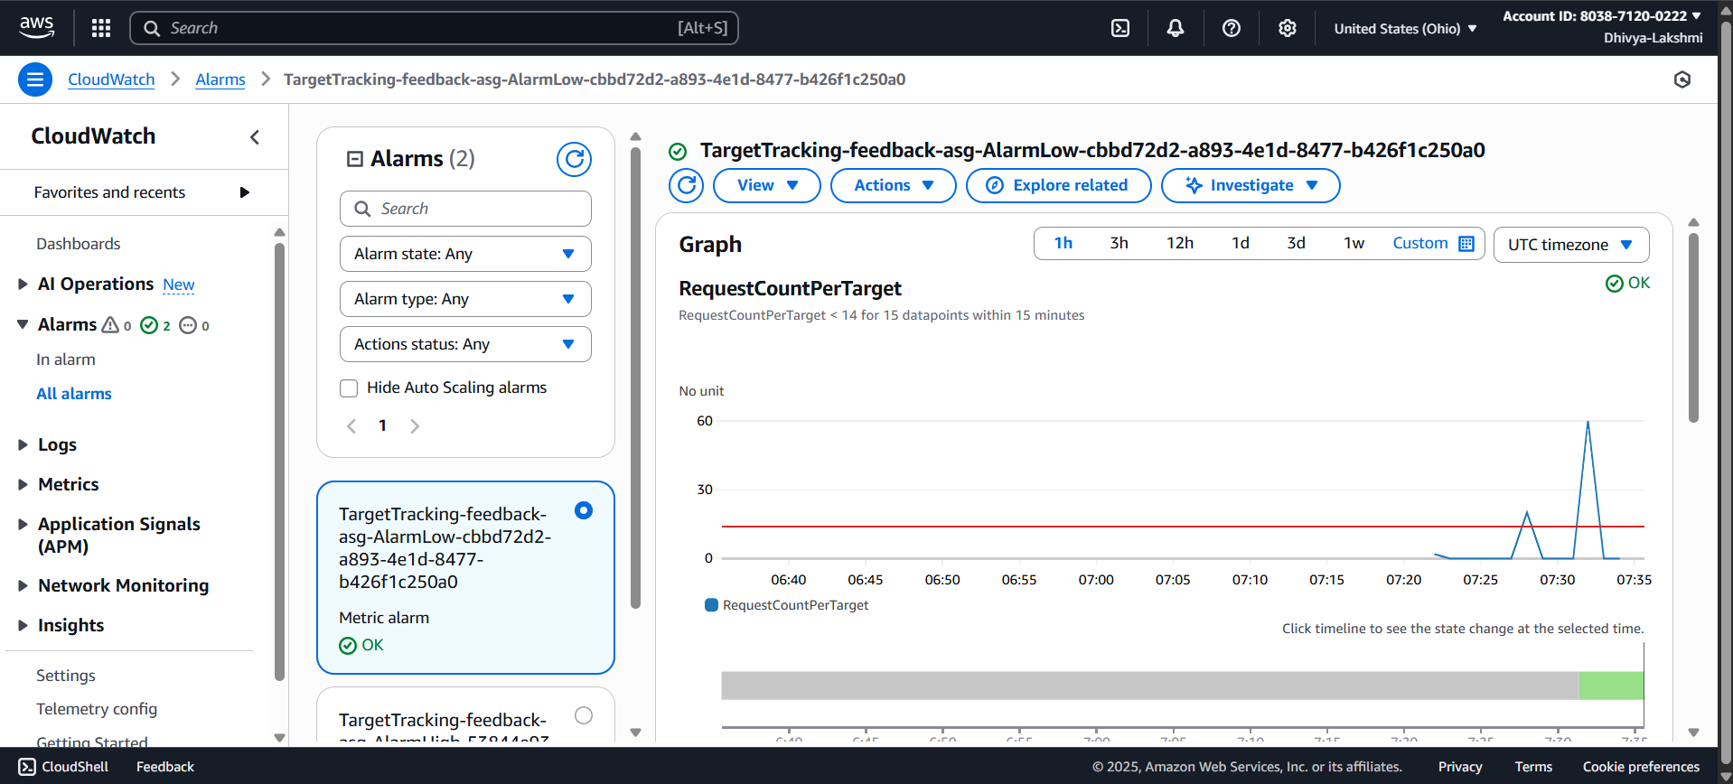

**PHASE 6: AMAZON QUICKSIGHT**

* Connect Quick Sight to **DB2 (Analyzed Feedback)**.
* Create **interactive dashboards** showing:
  + Sentiment trends (positive, negative, neutral)
  + Feedback categories
  + Real-time insights for monitoring customer opinions

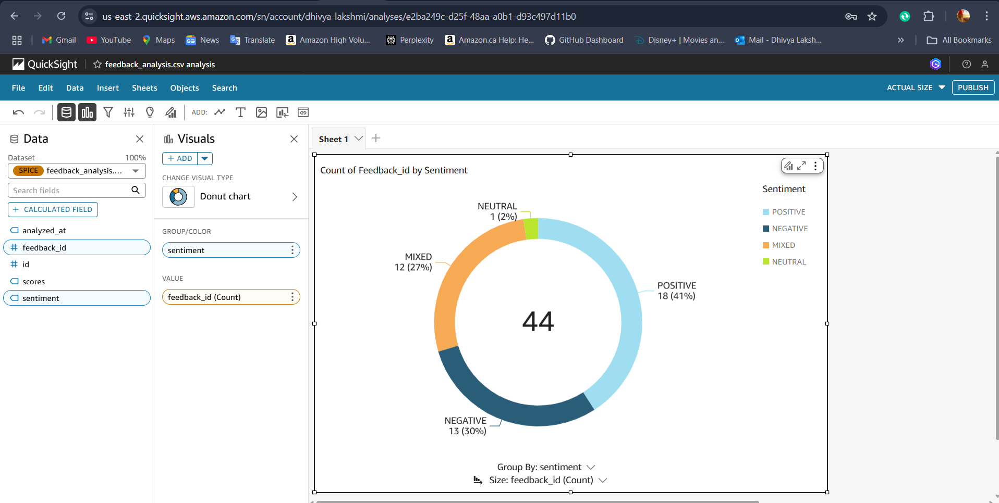

**PHASE 7: KEY LEARNINGS**

* **Multi-Tier Architecture:** Learned how to separate Web, App, and Database layers for better security, maintainability, and scalability.
* **AWS Services Integration:** Gained hands-on experience integrating EC2, RDS, ALB, Auto Scaling, Route 53, Amazon Comprehend, and Quick Sight.
* **Auto Scaling & Load Balancing:** Learned how to design systems that automatically scale based on traffic, ensuring high availability.
* **Security Best Practices:** Implemented Security Groups and IAM roles to restrict access and securely manage permissions.
* **Data Flow Understanding:** Learned end-to-end workflow from user input → database storage → AI analysis → visualization.

**CHALLENGES FACED**

* **ASG Scaling Issues:** Initially, instances did not scale because metrics from ALB were not triggering the policy correctly. Resolved by verifying CloudWatch metrics and cooldown settings.
* **ALB Request Distribution:** Understanding RequestCountPerTarget and ensuring the right load was sent to demonstrate scaling.
* **IAM Role Configuration:** Ensuring App EC2 had the correct permissions for Amazon Comprehend.
* **Database Connectivity:** Securing RDS in private subnets and allowing only App EC2 access.
* **Visualization Latency:** Ensuring QuickSight dashboards are updated near real-time with Comprehend-analyzed data.

**PHASE 8: FUTURE ENHANCEMENTS**

* **HTTPS Implementation:** Use AWS ACM to enable SSL and secure all traffic.
* **Advanced Analytics:** Implement more complex sentiment analysis, topic modeling, and trends over time.
* **Notification System:** Trigger alerts for negative feedback using SNS or Lambda.
* **Serverless Option:** Replace App EC2 with AWS Lambda to reduce costs and simplify scaling.
* **CI/CD Integration:** Automate deployments using Code Pipeline or GitHub Actions for faster updates.
* **Enhanced Dashboard:** Add filters, export options, and mobile-friendly views in Quick Sight.

**REAL-TIME USAGE SCENARIOS**

This system can be applied across industries to turn customer opinions into actionable insights:

* **E-Commerce Platforms**   
  Automatically analyze customer reviews and feedback on products to identify trending issues, improve product quality, and enhance customer satisfaction.
* **Hospitality & Travel**   
  Hotels, airlines, and travel agencies can collect guest feedback in real-time, measure satisfaction levels, and respond quickly to negative sentiment before it escalates.
* **Education & Training**   
  Universities and e-learning platforms can gather student feedback after lectures, courses, or training programs, helping educators refine teaching methods.
* **Healthcare**   
  Hospitals can analyze patient feedback to monitor service quality, detect dissatisfaction early, and improve patient care experiences.
* **Corporate HR & Employee Engagement**   
  Organizations can use this system internally to gather employee feedback, assess workplace sentiment, and make data-driven improvements to work culture.

**CONCLUSION**

The Multi-Tier Feedback Management System demonstrates how modern businesses can leverage cloud architecture, automation, and AI to process customer feedback at scale.

By combining EC2, RDS, ALB, Auto Scaling, Route 53, Comprehend, and QuickSight, this project showcases a secure, resilient, and intelligent system capable of handling variable workloads and providing actionable insights.

This hands-on project strengthened my expertise in:

* Cloud architecture design
* AWS deployment and automation
* AI integration for real-time insights
* Scalable and secure enterprise applications

This experience has built a strong foundation for architecting real-world enterprise-grade cloud applications.